3DHoles And Pins Kit

Project Goal
Create a set of parts that can be used to evaluate:
- Holes: create reference samples for 3, 4, 5, 6 mm for both holes and studs
Rev002
- Improve the quality using black text
- Print different size in different colors:
  - 3 mm – Orange
  - 4 mm – Yellow
  - 5 mm – Green
  - 6 mm – Blue

Holes

3 mm
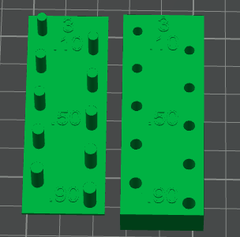 | 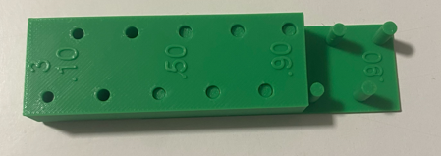

4 mm
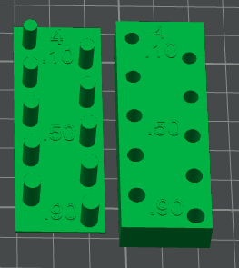 | 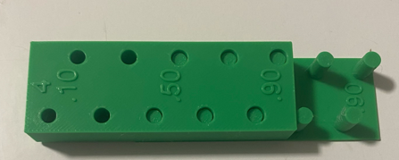

5 mm
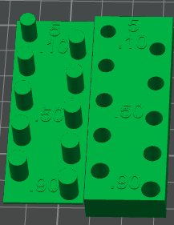 | 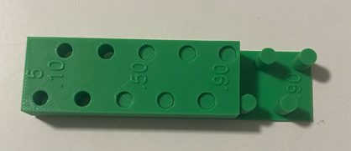

6 mm
This is different since I need to create space using a 7 mm circular slot.
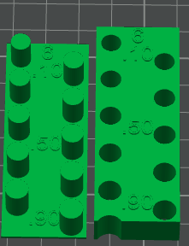 | 